Lab 1A: Mousetrap Vehicle Competition

EG-UY 1003 Y1B

Jason Yao

Team members: Aisha Al Mannaei

Date of experiment: 6th July 2015

Date due: 9th July 2015

**Abstract**

The objective of this lab was to build a car with LEGOs that was powered by a mousetrap capable of moving in a linear direction. A secondary objective was to optimize the linear distance traveled by the car, such that the linear distance traveled by the car was more than other EG 1003 teams’ cars. The car was successfully built under the design constraints outlined below, and placed in 3rd place in the EG 1003 competition, with a maximum linear distance traveled of 20 feet.

**Introduction**

This lab was a competition, with the only criteria judged being the linear displacement traveled by the car, in 3 trials in which the linear displacement was recorded. This meant that the total distance traveled was not counted (i.e. if the car traveled in a large arc, the total displacement would be from the start to where the car ended up, not along the arc that was traveled). If the car then collides with an object (e.g. a garbage can) during the trial runs, the distance would be measured at the position of collision. During the trial runs, the vehicle could not be pushed at the start, and could not be interfered with during the actual trial itself.

This meant that to maximize the linear displacement, we would have to try and minimize horizontal “drift” that could cause the car to move in a nonlinear fashion.

For this experiment, there were a number of constraints placed upon the design of the mousetrap car due to the competition between teams in the class. According to the EG 1003 Lab manual (2015), “Only LEGO parts provided may be used, the vehicle must be powered solely by the mousetrap, the vehicle must have at least one wheel (no projectiles allowed), and the mousetrap spring must not be physically altered.”

In order for our mousetrap car to move, a way of propulsion, or as the EG 1003 Lab manual (2015) describes, “energy conversion from a stored form into movement”, is required. A mousetrap is a simple device built to trap mice and other small animals. It is designed to be spring-loaded, and to release the spring catch when there is additional pressure on the trap (e.g. from the weight of a rodent). This results in the trap closing shut extremely quickly, trapping whatever set off the tap.

In our case, the mousetrap provides the stored energy inside its springs, with the propulsion converting from the stored potential energy inside the spring into kinetic energy when the mousetrap snaps shut. This conversion can be harnessed to turn an axle (the connecting rod between wheels), which in turn rotates the wheels, resulting in motion in a linear direction [Fig.1]. Our goal in this lab is to thus identify how to maximize the efficiency of the conversion between the potential energy in the spring to the linear distance traveled by the car.

Another design axiom that was to be incorporated was the idea of *rotational inertia*. As inertia is defined as the resistance of an object to change in its motion, rotational inertia is defined as the resistance of an object (e.g. the wheels) to changes to its speed (i.e. through friction between the wheel and the floor). Thus, it is our prerogative to try and increase rotational inertia while keeping the car light enough to move from a mousetrap.

**Procedures**

A mousetrap, 2 medium-sized LEGO wheels, 2 large LEGO wheels, 50cm of string, 2 2x8 flat LEGO boards to support the frame, a 8x16 flat LEGO board to hold the mousetrap, some scotch tape, 2 1x16 LEGO blocks to frame around the mousetrap, 4 LEGO axel rods (with two acting as holding bars to keep the mousetrap from slipping), and some miscellaneous decorative LEGO pieces were used to build the mousetrap car.

Firstly, the design constraints were reviewed, and an initial design of a 4-wheeled vehicle was determined to be a good starting point. As assembly was from scratch, we began by framing the car around the mousetrap, using 1x16 blocks to hold the mousetrap in place horizontally. Wheels were then added, with the larger set of wheels in the back, and the smaller set in front, with each set connected by an axel. Supports to the frame were added, and the string was attached to the mousetrap, and wound around the rear axel.

After assembly, the car was tested to see if it could move, which it did, but broke apart while moving. Additional supports to the frame were added, and holding bars were added as well, to keep the mousetrap from slipping. The first official trial was then held. After smoothing the contact points between the string and the car with scotch tape, the second official trial was held. It was then decided to try increasing the rotational inertia, by increasing the rear wheel size. After the changes were made, the third official trial was then held. After the 3 trials were completed, the maximum linear displacement the car could travel was found.

**Data/Observations**

The first (unofficial) test with the car was along an empty stretch of floor inside the lab room. The car could not hold together until the end, due to the large amount of force the mousetrap exerted. The estimated linear distance traveled was 3 feet.

The car was then redesigned to be able to resist the force from the mousetrap, by strengthening the frame around the mousetrap, and then adding in holding bars to keep the mousetrap in place.

After the redesign and reassembly, the car was then entered into an official trial, tested in the hallway outside of the lab room. A linear displacement of 5 feet was recorded.

The car was then looked at for friction points between the string and the car (places where the string could “catch” on the car, resulting in the string getting caught), and one particular spot along the rear was identified. Scotch tape was used to smooth the spot, in order to have smooth contact points between the car and the string.

After the tape was added, the car was then entered into its second official trial, tested in the hallway outside the lab room again. A linear displacement of 18 feet was recorded.

Increases to rotational inertia were then considered, with larger rear wheels added to the design. The original rear wheels were then replaced with the larger set.

After the wheels were swapped out, the car was then entered into its third and final official trial, tested again in the same hallway as the other trials. A linear displacement of 20 feet was recorded. The car finished in 3rd place in the EG 1003 competition [Fig.2].

**Figures and diagrams:**

Kinetic Energy

(mousetrap pulls on and rotates axel)

Trap released

Potential Energy

(stored in mousetrap)

Car moves forward

*Fig. 1: Energy conversion diagram*

|  |  |  |
| --- | --- | --- |
| **Team** | **Maximum Linear Displacement** | **Rank** |
| Richard, Harrison | 36 | 1 |
| Mike, Andreas | 27 | 2 |
| Jason, Aisha | 20 | 3 |
| Jeremiah, Timur, Nanda | 15 | 4 |
| Marcus, Ankita | 5 | 5 |

*Fig. 2: EG 1003 Lab 1 competition results*

**Discussion/Conclusions**

In conclusion, the car came in 3rd place in the EG 1003 competition, primarily because of the changes between the 1st and 2nd official trial (from a linear displacement of 5 feet to 18 feet). The potential cause for such a big improvement was through friction reduction along any contact points between the car and the string, since that was the only thing changed between the official trials.

The car could possibly be improved by increasing the rotational inertia even more so, via larger wheels. This results in diminishing returns the larger the wheels are, however, so eventually a limit would be hit in which any larger wheels would have a negative effect on the car (due to weighing too much). Thus, by finding this “sweet spot” for rotational inertia, we could optimize the linear displacement through a more optimized wheel set. The characteristics of the design that won the competition was a design based on a 3-wheel design, such that the front wheels were replaced with a single wheel in between where the original front wheels were. This design could also possibly be incorporated into future designs, as it appears to have a higher linear displacement, even though it had more theoretical horizontal “drift” than our designs.

**Bibliography**

NYU Polytechnic School of Engineering Faculty. “EG 1003 Lab Manual”.

*NYU Engineering Department*. January 22, 2015.

<https://manual.eg.poly.edu/index.php/Mousetrap_Vehicle_Competition>

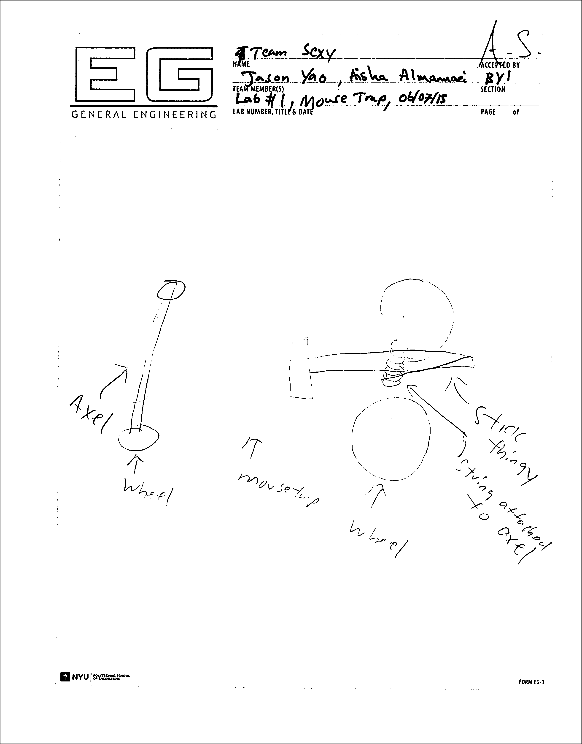

*Fig. 3: Initial design sketch*